**1.Explain and perform Importing table contents from Mysql to Hive using Sqoop.**

**Creating table in mysql:**

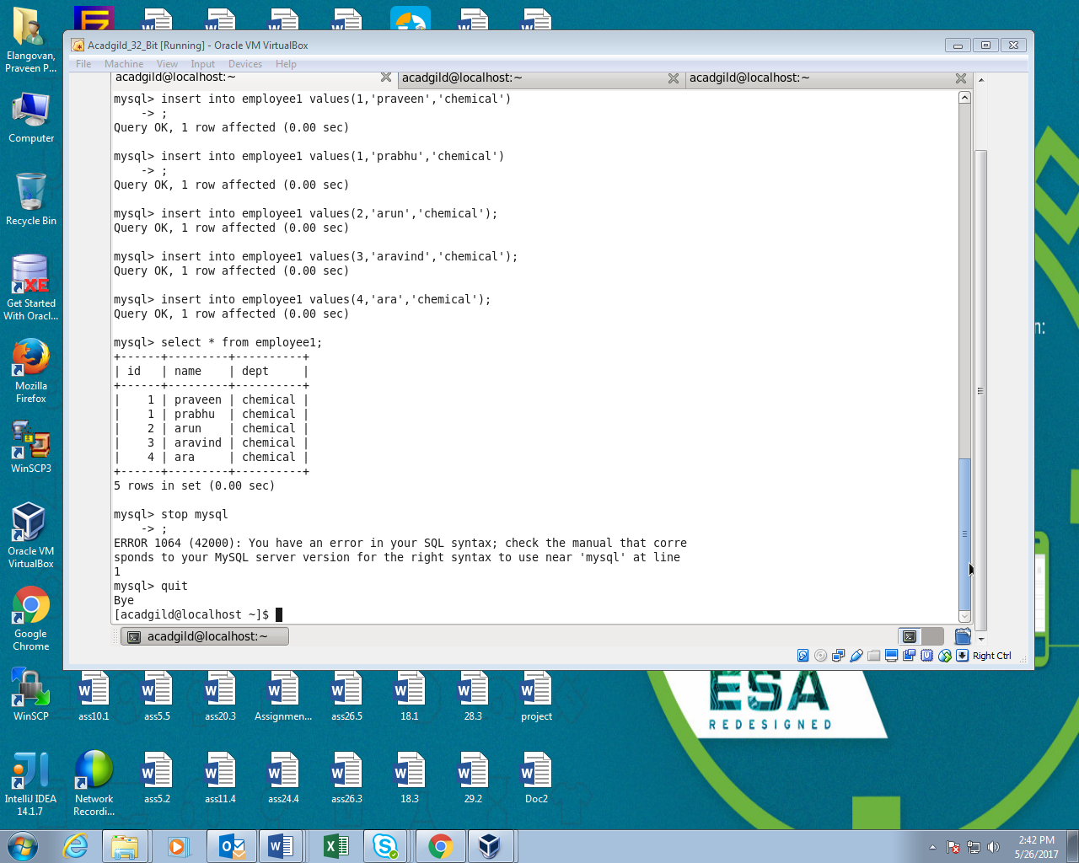

**Using Sqoop command transferring data from mysql to hive table:**

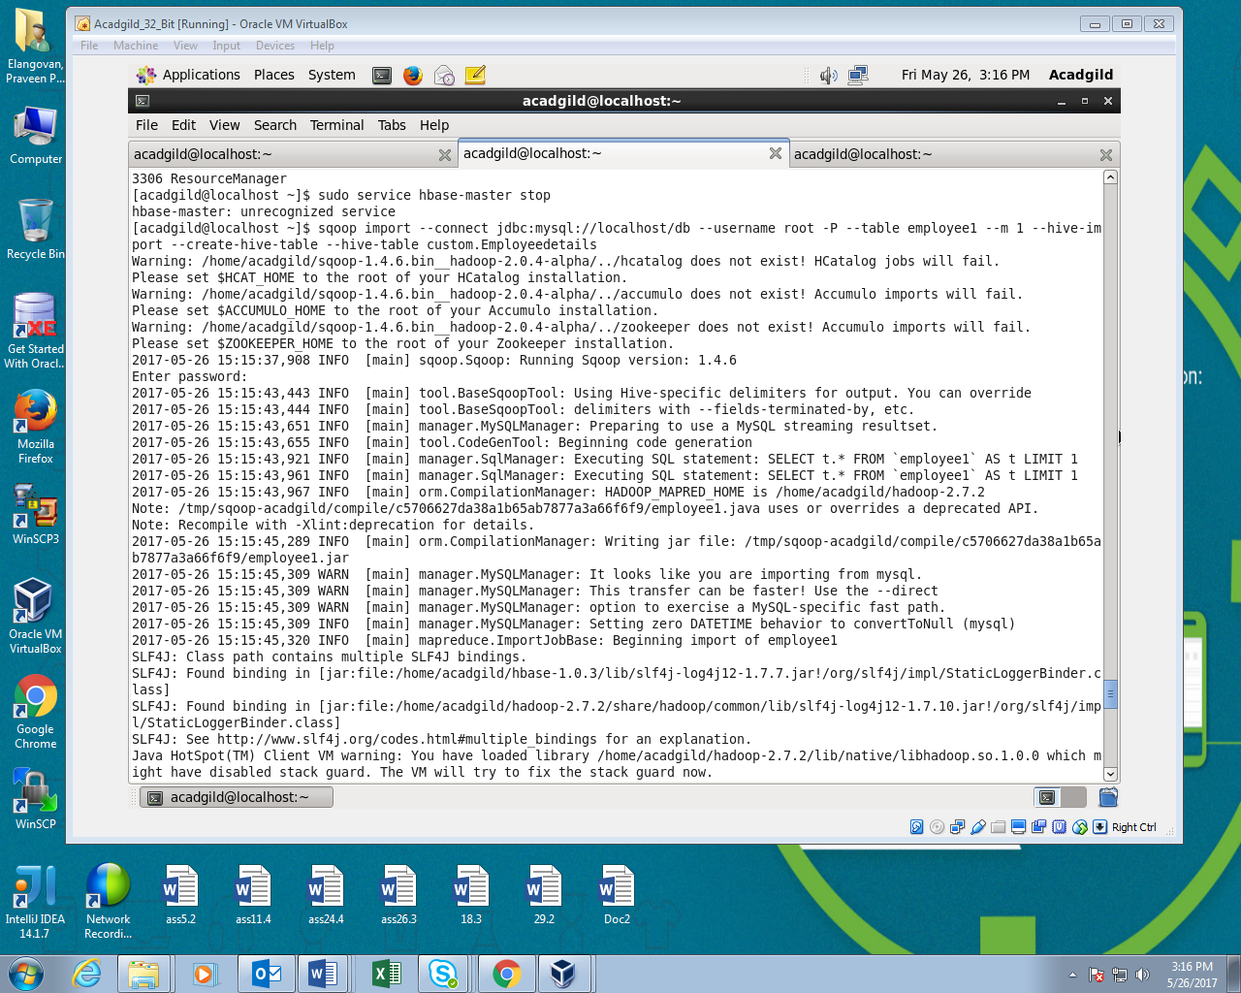

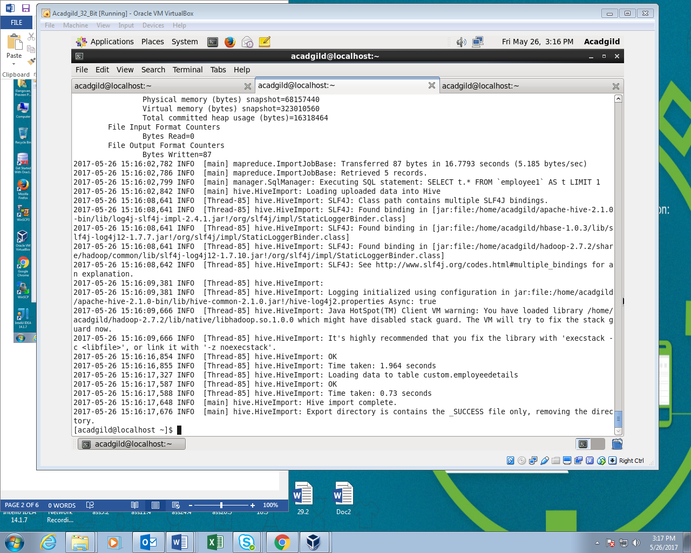

**OUTPUT:**

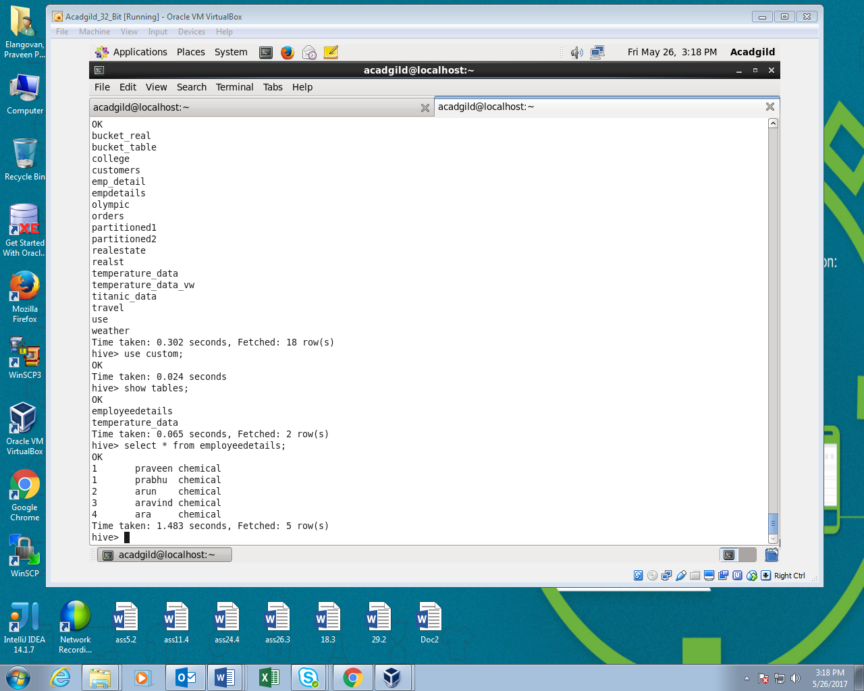

**2. Explain and perform Importing table contents from Mysql to HBase using Sqoop**

**Creating table in Hbase:**

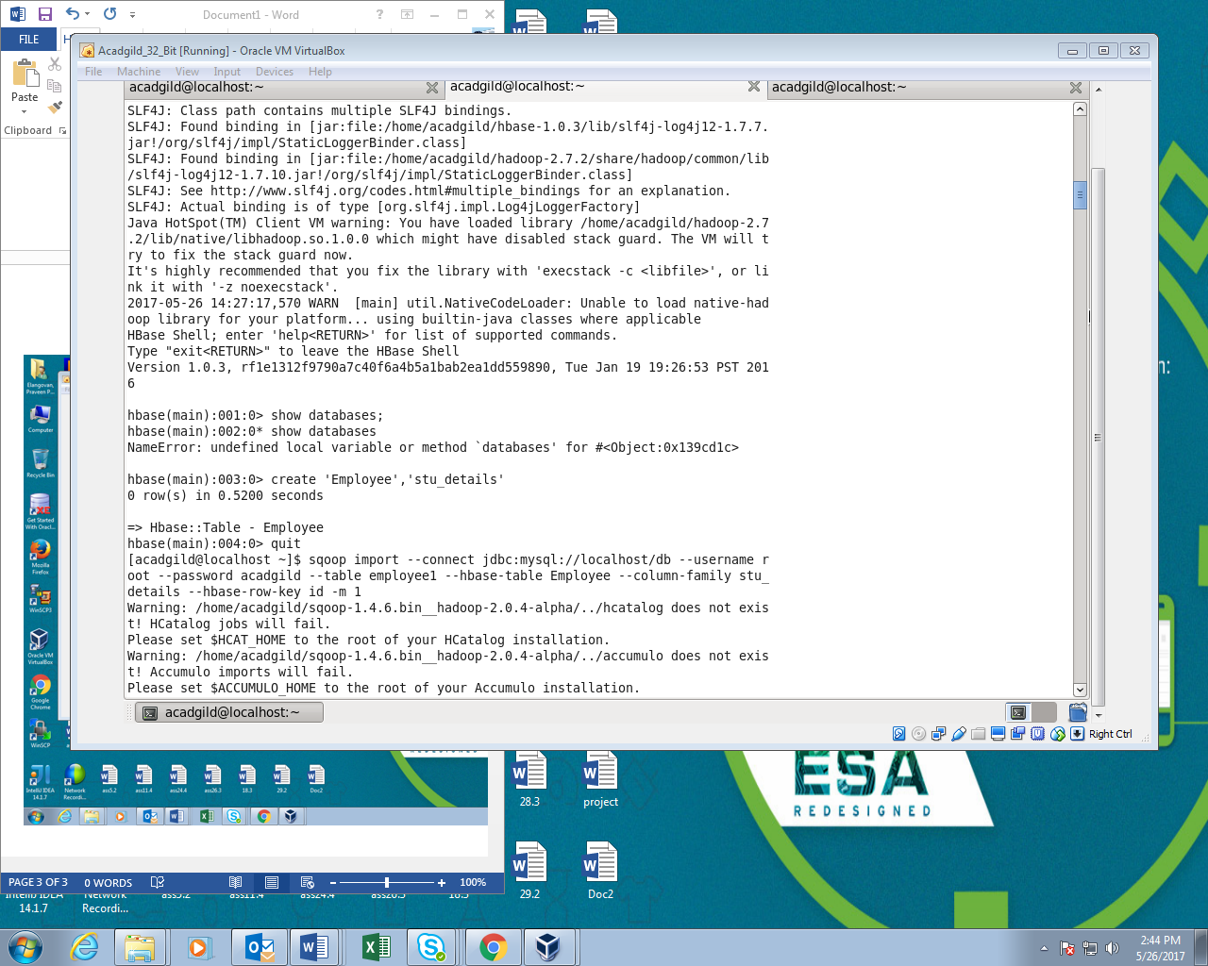

**Using sqoop command inserting data from mysql to hbase table**

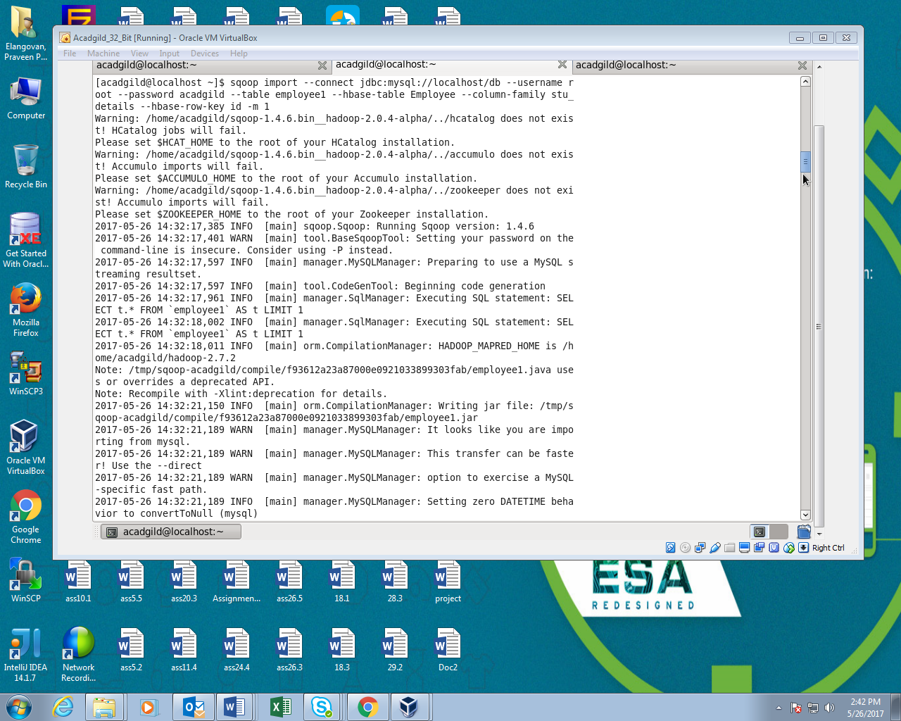

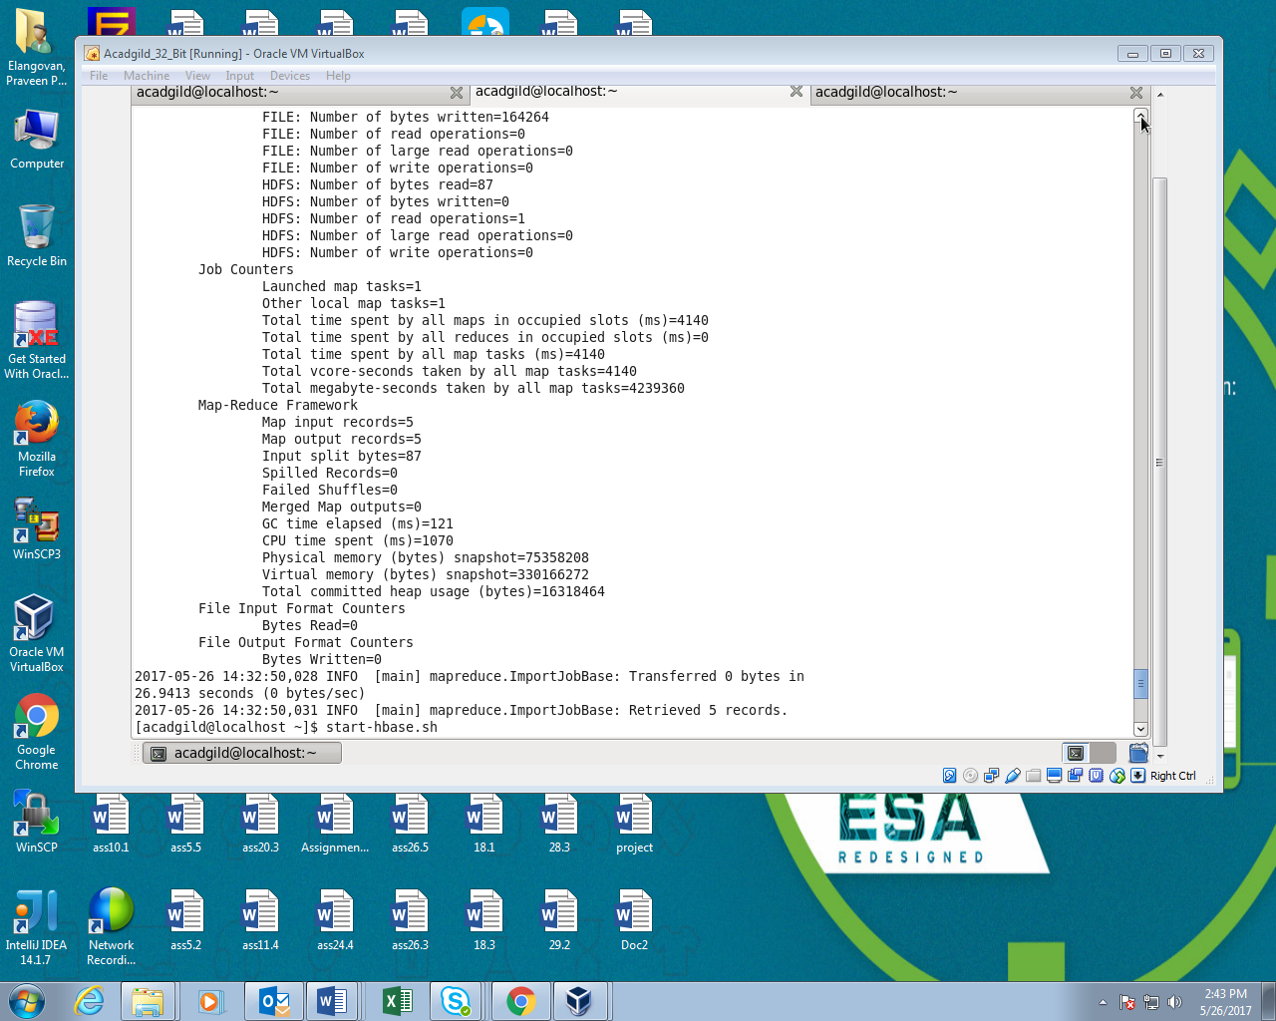

**Output:**

